**USMAN MARUF**

**3041120**

**COMPUTER ENGINEERING 4**

**3.0**

**a.** T = 1/4000;

tt = -T:0.000014:T;

tm1 = (37.2/10)*T; tm2 = -(41.3/14)*T;

**b.** A1 = 23; A2 = 1.2*A1;

x1 = A1*cos(2*pi*4000*(tt-tm1));

x2 = A2*cos(2*pi*4000*(tt-tm2));

plot(tt, x1, 'b-'), grid on

xlabel("Time");

ylabel("Amplitude");

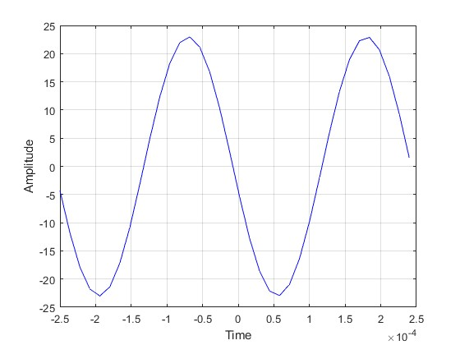

plot(tt, x2, 'r-'), grid on

xlabel("Time");

ylabel("Amplitude");

title('Second plot')

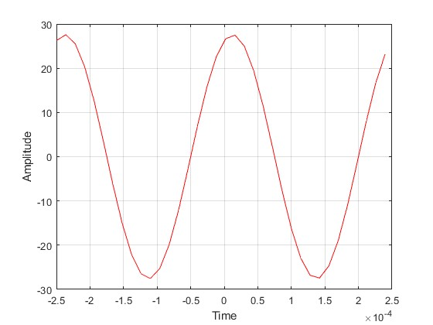

**c.** x3 = x1+x2;

plot(tt, x3, 'b-'), grid on

xlabel("Time");

ylabel("Amplitude");

title('Combined signal')

**d.** subplot(3,1,1);

plot(tt, x1, 'b-'), grid on

xlabel("Time");

ylabel("Amplitude");

title("First Plot");

subplot(3,1,2);

plot(tt, x1, 'b-'), grid on

xlabel("Time");

ylabel("Amplitude");

title("Second Plot");

subplot(3,1,3);

plot(tt, x1, 'b-'), grid on

xlabel("Time");

ylabel("Amplitude");

title("Maruf Usman");

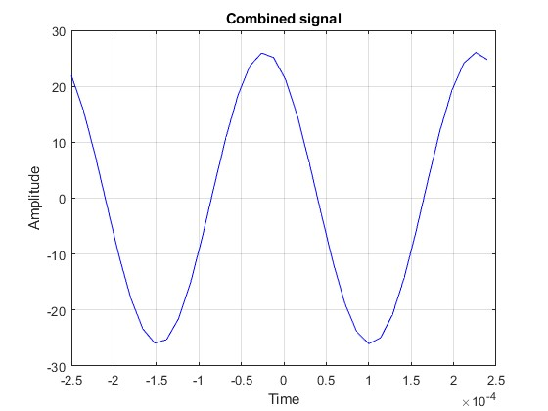

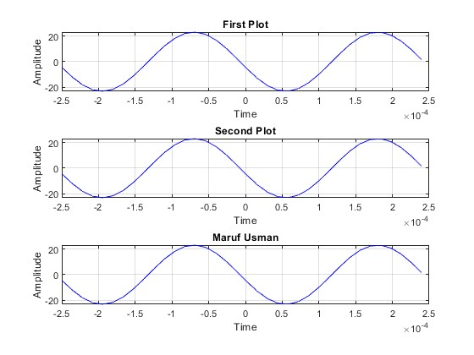

**3.1.** A1=21.9,A2=26.36,tm1=0.0093,tm2=0.00258,A3=5.796

**3.2.** temp = real(A1*exp(j*2*pi*4000*-tm1)*exp(j*2*pi*4000*tt));